HOW TO… Online Enrollment @ European-University Viadrina
Follow this step-by-step guide to complete your online enrollment on viaCampus, our university platform. If you encounter any issues or have questions during the enrollment process, please contact us via e-mail at students-in@europa-uni.de.
1: Log-In
You have received an e-mail from the European University Viadrina with your login details:
Username: euvXXXXX
Password: XXXXXXXX

2: ViaCampus Homepage
Online enrollment takes place on the viaCampus platform: https://viacampus.europa-uni.de/
You can change the language to English in the upper right corner.
Log in using the credentials provided in the email.

3: Change your password
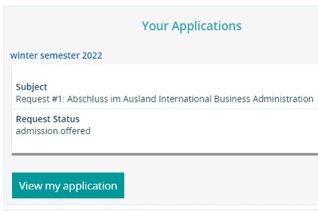
After you have logged in, you'll need to change your password. Please choose a secure password and remember it.
4: View my application
After changing your password, you will return to the homepage. Click on "View my application" to start the online enrollment process. The "View my application" option should be in the upper left corner.
If it does not appear, access it by selecting "Studies offered" from the menu and then "Online application."

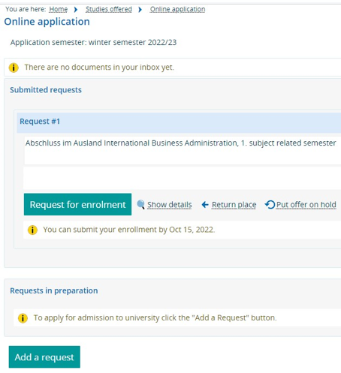
5: Request for enrollment
Click on "Request for enrollment."
Please avoid clicking “Add a request.”

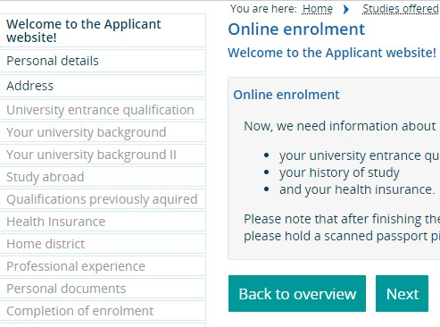
Now, you should be on the correct page. Click "Next.”
You can always navigate back during the online enrollment process.

6: Personal Details
Review your personal information. Check and update, if necessary. Core data, such as your name and date of birth, cannot be edited. If you find errors here, please contact us.
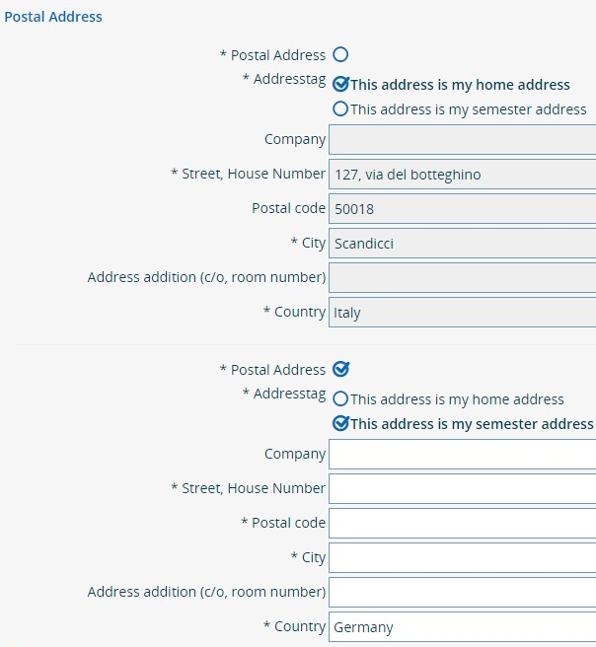
7: Address
This section concerns your address. The pre-filled address is your home address. If you know your address in Frankfurt (Oder), you can add it as your “semester address” by clicking “New Address”.

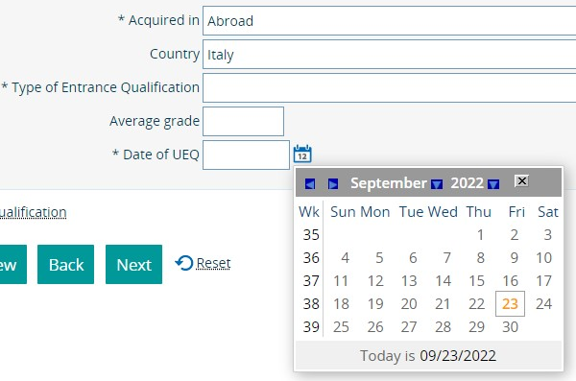
8: University Entrance Qualification
This is your School Leaving Certificate. Please specify the last/highest school you attended before starting your university career. Use the calendar option to select the date. Your grades must be converted to the German system:
- Best grade: 1.0
- Lowest passing grade: 4.0
- Fail: 5.0
Grade conversion online: https://www.tum.de/en/studies/application/application-info-portal/grade-conversion-formula-for-grades-earned-outside-germany

9: Your University Background
You can skip this section, but if you're transferring from another university to Viadrina, please fill in the mandatory details. If not, click “Next.”

10: Your University Background II
For master's students: Record your bachelor's degree details. You can also add a prior master's degree by clicking “Add degree.” Bachelor's students should leave this section blank and click “Next.”

11: Study abroad
This section is for degree-seeking students only. Please leave it blank and proceed.

12: Qualification previously acquired
Leave this section as it is and click “Next.”

13: Health Insurance
D. https://www.europa-uni.de/en/internationales/Students/Incomings/health-insurance/index.html
You will now be directed to the “Health insurance” tab. Please fill in the necessary details. Depending on your scenario, follow the instructions provided about EHIC, GHIC, A/T 11, or German statutory health insurance. Note that foreign or private health insurances aren't generally accepted, with exceptions mentioned.
please show your insurance documents to a German health insurance company and ask for confirmation, that you don’t need any German health insurance. This confirmation is needed for your enrollment documents. If you get a confirmation, please select “exempted” in the online-enrollment form.

Scenario 1: If you are
- an European citizen and own a valid European health insurance and EHIC (European Health Insurance Card)
- have a UK EHIC or GHIC (Gobal Health Insurance Card)
- an Exchange Student from Turkey and have the A/T 11
Scenario 2: Without EHIC or A/T 11, you need to buy a German statutory health insurance. Please take a look on our website stating different options for German health insurance companies.
D. https://www.europa-uni.de/en/internationales/Students/Incomings/health-insurance/index.html
Please note that other health insurances from abroad and private health insurances are not accepted.
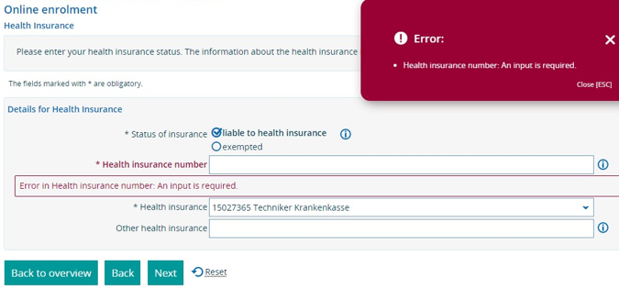
Private health insurances are only an option for students older than 30 years.
The health insurance number is mandatory: if you need to get a German health insurance, you need to wait with the online-enrollment process until you get your personal health insurance number.

14: Home district
Add your country of origin if it isn't already shown, then click “Next.”

15: Professional experience
Skip this section. If „No“ isn‘t already selected, ensure you select it for both queries before proceeding.

16: Picture upload
Picture Upload Time! Select a good photo, easiest and safest would be a photo valid for a passport. Please don’t pick a bathroom selfie or group photo.
Ensure your face is clearly visible, avoid filters, and ensure the file size is 1 MB or less. Check the “Chip card” box before moving on.

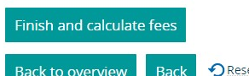
17: Online Enrollment Completed
You're almost done! Click “Finish and calculate fees” and download the provided PDF. This document contains important details, including your matriculation number and login information.

Important information about the Downloaded PDF
Sign the first page of the downloaded PDF. Combine this signed page with the health insurance confirmation and proof of semester contribution payment. Submit these documents either online (students-in@europa-uni.de) or at the ServicePoint (https://www.europa-uni.de/de/struktur/verwaltung/dezernat_1/servicepoint/index.html).

After handing in the signed document with your health insurance confirmation and your semester contribution payment confirmation, it takes 2 - 4 weekdays to produce your Student ID card, which is also your transport ticket (semester ticket).

