With a double click you can edit the information above!

Studying Abroad Experience Report

- Are we allowed to publish your report anonomiously on our webpage (without your name and e-Mail)?
[+] Yes [ ] No

- Are we allowed to forward your report and contact information to a Viadrina student on request?
[ + ] Yes [ ] No

- Please confirm hereby that you did not mention names of a third party (lecturer, landlord etc.)
[+] Yes [ ] No – in this case your report won‘t be published

- Please be aware that all the published photos in this report have to be taken by you and are not the property of a third party. By sending this report you are giving us the legal right of use for your pictures (if we publish the report). The copyrights still belong to you after all.
[ + ] Yes, I confirm that all photos are mine.

We would appreciate it if you could include the following topics (the report should be at least two pages long, there is no maximum):

- Preparation: Recommendations about preparing to leave, for example (if applicable) Visa, insurance, travel? How was the application process at the university abroad? Were there any introduction events? Were they obligatory and when did they take place? Was there a Buddy program or tutors?
Application to host university was not hard, the 2nd round was guided by Viadrina International office, and you need the same pack of documents as for the first round. For the people who never lived abroad (outside of the EU) paperwork for visa might seem complicated. There was a lot to do document-wise, and because of the Korean government's strict regulation regarding Covid-19, you will need to do self-isolation and prepare a lot of additional documents. I would say be ready for a lot of paperwork.
An important point for preparation is getting Korean apps, you would really need them.

My advisory list:
- Kakao Talk (messenger like WhatsApp),
- Papago (translation from and to Korean),
- Korail (for train tickets)
- Kakao or Naver map (Google maps do not work good in Korea, make sure to have one of these maps when you arrive),
- Kakao T (for the taxi),
Due to the Covid-19 introductory event at the host university was held online. But I also think it was a little late since it took place in 2nd study week. A lot of paperwork and other registration points had to be done by this time. If you are lucky with the buddy assigned by the host university, he or she would help you and the integration and settlement process would be easy. Personally, I was not so lucky, so I had a lot of difficulties figuring things out. My advice would be to ask other exchange students or international students that study at PNU on regular basis. I also know a lot of exchange students who never saw their Korean buddies and got no help from them at all. On the other hand, some become good friends.

- Accommodation: How did you find your accommodation? Any tips about mistakes that should be avoided? Were there any special student accommodations? The cost of rent? Which area of living would you recommend?
I lived in the dorm for my exchange semester, PNU provides you with all details on how to apply, pay, and so on. However, the dormitory is very different from the one we used to in Germany. It is gender-separated, only people who live there are allowed inside, there is a huge list of rules and a penalty point system which you get for valuating rules. For me, the biggest problem was the absence of the kitchen you are basically forced to eat food from the dorm cafeteria, which did not go well with my health. And one more valid point is that there is a curfew, you cannot enter the dormitory between 1 am. and 5 am. The price for it is nice it is around 280 euro per month with meals included twice a day. Another good point is, you can always move out of the dorm, if you notify them 2 weeks upfront you will get money back. It is possible to do it even in the middle of the semester.
If you would like to live in your own apartment, I would not advise getting Airbnb, because they are more expensive, maybe only for the first few weeks before you find another place. The easiest and fastest way is to go to a real estate agent once you arrive, in the area you want to live, and they will show you options right away. This is very popular in South Korea and that is how locals find homes for themselves. Consider taking a Korean-speaking person with you or using and remember it is fine to negotiate the price. Usually, you would need to pay around 200 000 – 350 000 KRW (147 – 258 euro) per month for the studio apartment and a deposit that ranges from 780 euro to 1468 euro. I can advise 2 apps for real estate search: 직방, 다방.
Shared apartments are not common so it would be easier to find 1 room studio. I would recommend near the university or at Seomyon (this is a youth district with a lot of cafes, bars, clubs, and shops).

- Studying at the university abroad: How was the day to day life on campus? Was the attendance mandatory? Which courses did you take? Were you allowed to take courses from different faculties? Please attach links to the course list if possible. How did the exams take place? Were there any language courses? What is your overall opinion of the university in general? How well did the university take care of international/exchange students?
Unfortunately, due to limitations, the student life was mainly based on classes. However, I took part in 2 student clubs and several university activities. I would advise checking the (International Notice) page on the PNU website, they always post their upcoming activities. Here is the link - https://his.pusan.ac.kr/international_eng/index..do
Attendance is a part of the grade at Pusan National University, and you are only allowed to skip 2 classes for each course you take. You can choose courses from different faculties, but you will get in only if there is a place left and if the faculty approves it. The way to register for them is harder because you need to feel separate forms and all of them are in Korean. I took a course from the International and Area studies department and Korean Language. I was satisfied with my classes.
https://e-onestop.pusan.ac.kr/menu/foreign/N02/N02004 - Link to the course list.

- Day to day life and free time: How high are the costs of living in total? How much money should be accessible monthly? How much does the public transportation cost? What can an exchange student do in their free time? What did you do?
Busan has many beautiful places and nature: mountains, rivers, beaches, and the sea. Many exchange students also travel around the country a lot. I would say the costs of eating out are cheaper than in Germany. It is popular to go to Karaoke, bars, and clubs in your free time, you can see a lot of Koreans doing this in the evening after work or study. And all these activities are cheaper than in Germany.
However, fresh fruits, vegetables, and berries are more expensive, and sometimes cooking at home is pricier than eating in a restaurant. Also, “European” food is quite expensive. I am missing the cheese and real bread. Public transport costs around 1-2euro per ride, depending on how far you are going. I would advise buying a T-money card in any convenience store (like 7 eleven, GS25, emart24) you can find them in every corner, and take public transport with this card. And in case you take the bus within 30 minutes after your metro or another bus right, it would be for free.
The costs of living depend on where you stay and what you do, by staying in the dorm I would say 500 euro a month would be enough.
- Conclusion: worst and best experience
To conclude I really liked my experience abroad, it was a great opportunity to discover an extremely different culture, learn a new language, meet people all around the world and broaden my horizons. From my travel experience, it was also a complicated trip, since a lot of people do not speak English in Busan and my Korean is not good. There were a lot of misunderstandings and milestones. South Korea also has a lot of unspoken “social” rules that are hard to be aware of if you are a foreigner.

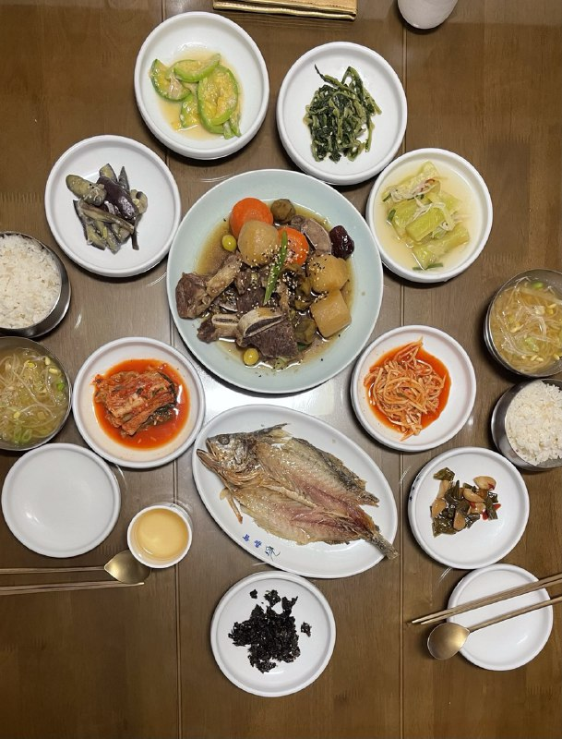
Picture. Korean Food Servings

